**Glass for tray**

4 pieces ¾” x 12” Wissmach 96-19 Transparent Peacock

3 pieces 1” x 12” Oceanside 130.8 Transparent Pale Blue  
2 pieces 1 ½” x 6” Oceanside 200 Opal White

3 pieces ¾” x 6” Oceanside 200 Opal White

4 pieces ¾” x 6” Wissmach 96-14 Opal Blue

**Glass for stand**

2 pieces 1” x 9” Oceanside 130.8 Pale Blue

2 pieces ¾” x 5” Wissmach 96-14 Opal Blue

2 pieces ½” x 5” Oceanside 200 Opal White

4 pieces ¾” x 2 ½” Wissmach 96-19 Peacock

4 pieces ¾” diameter clear pebbles

**Stainless steel weave molds**

2 – ½” x 8”  
3 – ¾” x 8”

12” x 12” **Stainless steel reversible mold**

This project was done with steel weave molds but could have been done with ceramic molds or strips of 6mm thick float glass coated with boron nitride or cover with strips of kiln paper. This was done using 1 ½” and ¾” wide molds with 1” spaces but could be done in any variety of mold sizes and spaces you like.

**Set out the strips to slump**

Kiln wash the molds and set them out in the desired pattern with a 1” space between each mold. As an alternative to kiln wash you could use boron nitride or strips of kiln paper. Take care to be sure there is at least a 3mm space between each glass strip to ensure they don’t touch and tack fuse together.

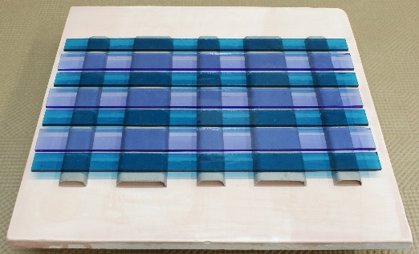

**Fire to tack fuse**

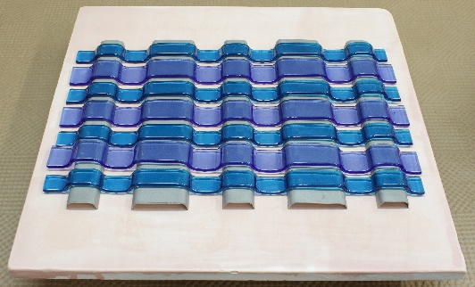

**Remove the glass strips** from the molds and turn every second strip over to create the alternating pattern needed to produce a weave.

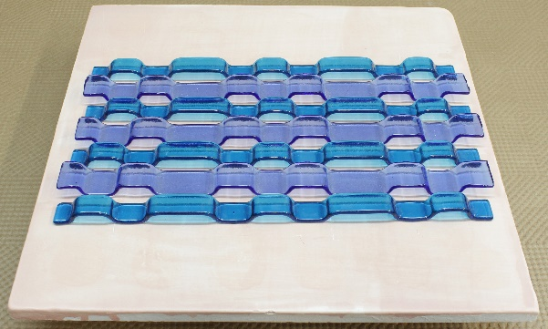

**Insert the cross weave pieces**. It is IMPORTANT you DO NOT cut these cross pieces in advance. You cannot be certain the glass strips will have slumped enough to allow the predicted size cross weave pieces to fit in. Wait until the project is ready for the cross pieces then test to confirm what size of glass piece fits.

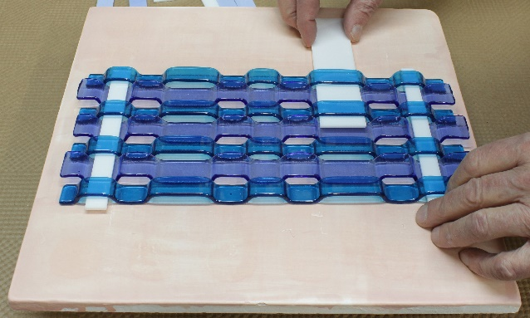

Fire to tack fuse when all the cross pieces have been inserted through the weave strips.

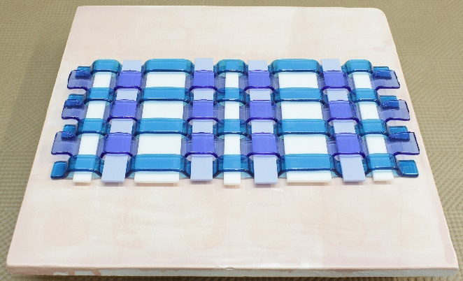

**Making a stand** for the tray is completely optional. You can eliminate it if you with. It’s only to display the woven tray. Lay out the pieces for the stand. This photo shows one possible design for a stand but you can have fun experimenting with different designs for stands for your projects. The 4 clear glass pebbles are not critical but they work well to hold the tray elevated from the stand and act as feet to stabilized the woven tray.

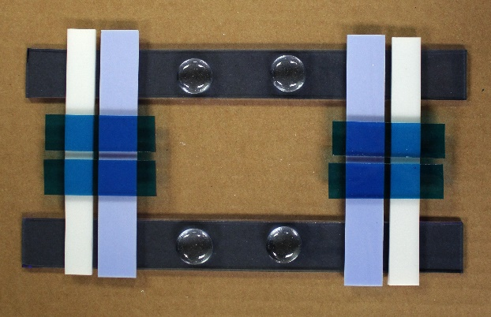

**Tray with stand after tack fusing.**

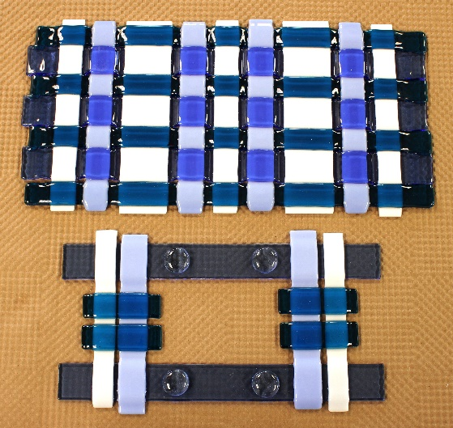

**Set the stand on the metal mold** **and fire to drape.** This mold was sprayed with boron nitride but you can also use kiln wash or a piece of kiln paper.

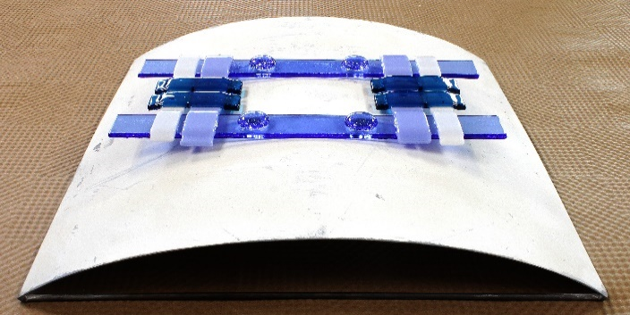  
  
**Set the tray in a metal mold and fire to slump.** The drape and slump firing for this project was done in a steel reversible mold to ensure the drape and slump were the same arc but you could do this in any mold. The mold was sprayed with boron nitride but you can also use kiln wash or a piece of kiln paper.

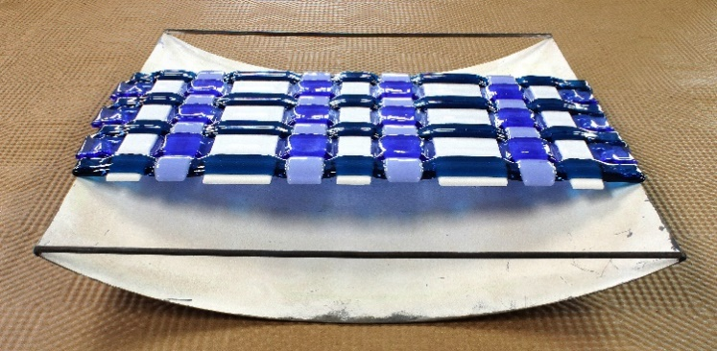

**Completed stand after drape firing.**

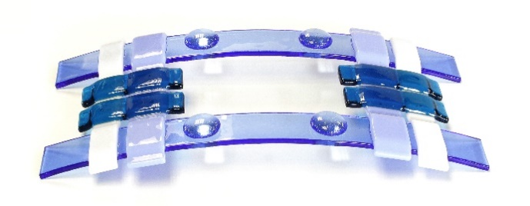

**Woven glass tray after slump firing.**

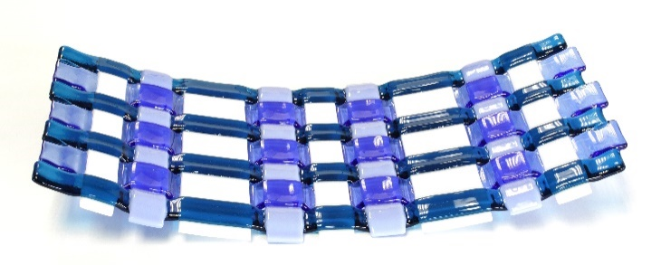

**Tray set parallel on the stand.**

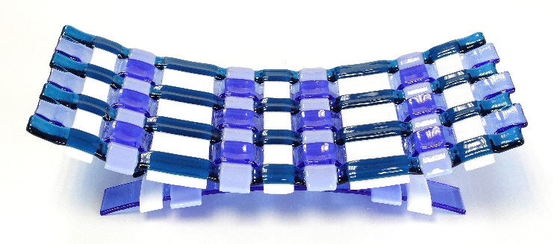

**Tray set perpendicular to the stand.**

By keeping the tray and stand separate you have the option of displaying them either way.

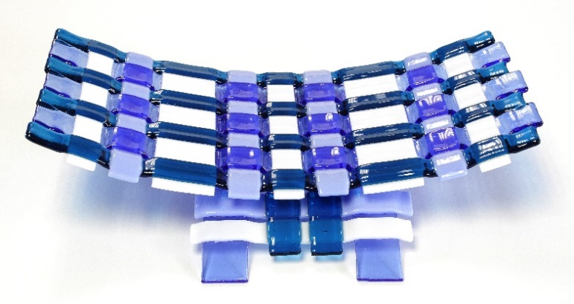

**FIRING SCHEDULES for COE 96 glass**

**Weave strips**

|  |  |  |  |  |  |
| --- | --- | --- | --- | --- | --- |
| **SEG** | **RAMP**  **C°/hr** | **RAMP**  **F°/hr** | **TEMP**  **°C** | **TEMP**  **°F** | **HOLD**  **min** |
| **1** | 205 | 400 | 540 | 1000 | 20 |
| **2** | 425 | 800 | 732 | 1350 | 30 |
| **3** | 9999 | 9999 | 515 | 960 | 60 |
| **4** | 205 | 400 | 315 | 600 | 0 |

**Weave Assembly**

|  |  |  |  |  |  |
| --- | --- | --- | --- | --- | --- |
| **SEG** | **RAMP**  **C°/hr** | **RAMP**  **F°/hr** | **TEMP**  **°C** | **TEMP**  **°F** | **HOLD**  **min** |
| **1** | 150 | 300 | 540 | 1000 | 20 |
| **2** | 425 | 800 | 732 | 1350 | 15 |
| **3** | 9999 | 9999 | 515 | 960 | 60 |
| **4** | 150 | 300 | 315 | 600 | 0 |

**Drape & Slump**

|  |  |  |  |  |  |
| --- | --- | --- | --- | --- | --- |
| **SEG** | **RAMP**  **C°/hr** | **RAMP**  **F°/hr** | **TEMP**  **°C** | **TEMP**  **°F** | **HOLD**  **min** |
| **1** | 150 | 300 | 540 | 1000 | 20 |
| **2** | 425 | 800 | 675 | 1250 |  |
| **3** | 9999 | 9999 | 515 | 960 | 60 |
| **4** | 150 | 300 | 315 | 600 | 0 |

The same firing schedule can be used for **COE 90** glass by adding 20°F to the top performance temperature.

As slump firing is usually done at 1250°F (675°C)

but much higher temperature is needed to soften the glass enough to slump into the narrow span between the molds.  
  
A slump firing is usually completed in 20 minutes but longer hold time is need to give the glass time to slump into the narrow span.

A simple tack fuse can usually ramp faster but the spaces between the glass strips slow down heat transfer so a slower ramp is need to compensate.

A simple drape or slump can usually ramp faster but the spaces between the glass strips slow down heat transfer so a slower ramp is need to compensate.