The term “squared away” means “completely organized”. I use that name for these projects because it refers to how the design is created by an organized structure of squares but also by the open spaces left from that organized structure.

You can cut up glass specifically for projects or, like I did, you can cut different size squares from whatever bits and scraps of glass you have left over from other projects Use different size squares to create interesting open grid patterns using empty space between the squares as part of the design.

You can build a design as you go or plan a design in advance. When you design a grid pattern it’s important to remember to plan for an even number of squares and an uneven number of spaces between the squares. The number of spaces between squares will be one less than the number of squares. If the pattern you plan has 8 squares, there will be 7 spaces between the squares.

**SQUARED AWAY – Black Iridescent**

**Materials needed:**

16 pcs 2” x 2” SPE 1009/I black iridescent glass

9 pcs 1” x 1” SPE 1009/ black iridescent glass  
9 pcs 2” x 2” OGT 100.3 clear

Experiment with different configurations. Here I set out the 2 inch square iridescent black pieces in a pattern 4 across and 4 high with 1 inch square pieces connecting at each corner.

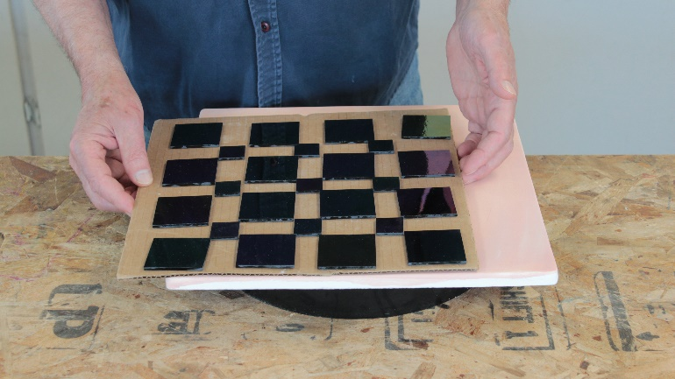

You can experiment with different colors and different design combinations and when have a design you like, transfer it to a kiln shelf. If you prefer, you could instead build your assembly right on the shelf inside your kiln. You can experiment with different size squares and a variety of colors for interesting effect.

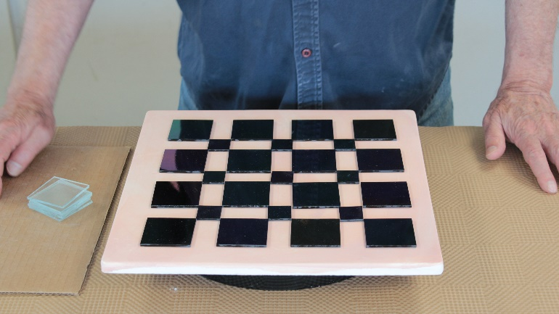

Place the 2 inch clear glass squares on top of the 1 inch black iridescent squares. Set them in place so the overlap of the clear glass squares on the larger black iridescent glass squares is equal at each corner.

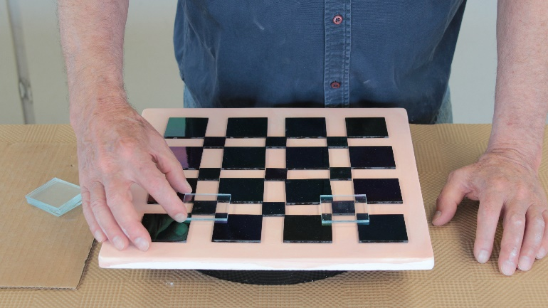  
  
Check to be sure all your squares are squared off and in parallel rows.

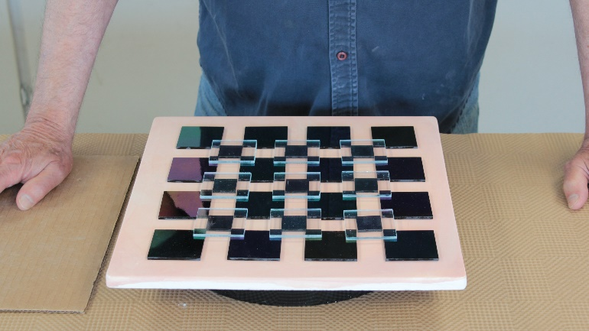  
  
**FIRING SCHEDULE – Tack Fuse**

|  |  |  |  |  |  |
| --- | --- | --- | --- | --- | --- |
| **SEG** | **RAMP**  **C°/hr** | **RAMP**  **F°/hr** | **TEMP**  **°C** | **TEMP**  **°F** | **HOLD**  **min** |
| **1** | 205 | 400 | 540 | 1000 | 20 |
| **2** | 425 | 800 | 731 | 1350 | 15 |
| **3** | 9999 | 9999 | 515 | 960 | 60 |
| **4** | 205 | 400 | 260 | 500 | 0 |

Load your project in the kiln and fire to tack fuse.

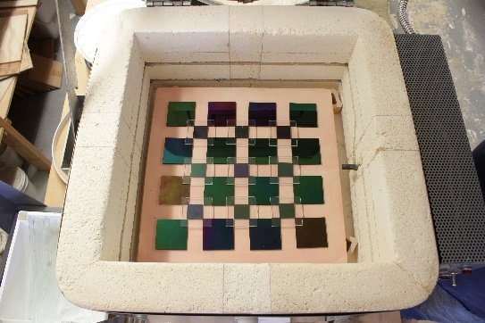

Here’s the finished project tack fused then slumped into a tray shape.

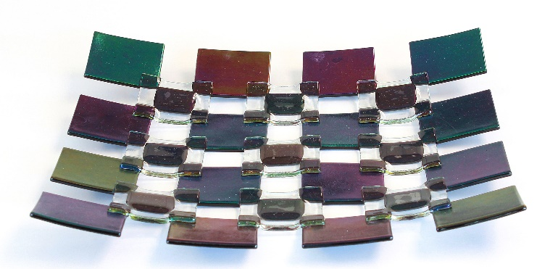

**FIRING SCHEDULE - Slump**

|  |  |  |  |  |  |
| --- | --- | --- | --- | --- | --- |
| **SEG** | **RAMP**  **C°/hr** | **RAMP**  **F°/hr** | **TEMP**  **°C** | **TEMP**  **°F** | **HOLD**  **min** |
| **1** | 205 | 400 | 540 | 1000 | 20 |
| **2** | 425 | 800 | 675 | 1250 | 20 |
| **3** | 9999 | 9999 | 515 | 960 | 60 |
| **4** | 205 | 500 | 260 | 500 | 0 |