**SQUARED AWAY – Rainbow Sconce**

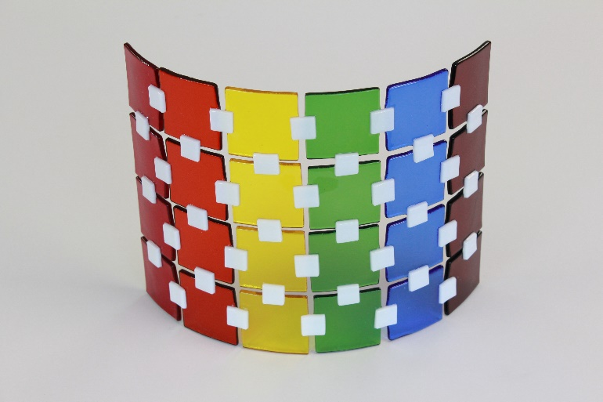

**Materials needed:**

4 pieces 1 ½ inch square OGT 151 Red glass

4 pieces 1 ½ inch square OGT 171 Orange glass

4 pieces 1 ½ inch square OGT 161 Yellow glass

4 pieces 1 ½ inch square OGT 123 Medium Green glass

4 pieces 1 ½ inch square WIS 96-16 Sapphire Blue glass

4 pieces 1 ½ inch square OGT 146 Dark Purple

38 pieces ½ inch square OGT 200 White Opal glass.

Rainbows are always pretty. I thought it would be fun to make a square away rainbow sconce.  
  
  
Set out the first row with one of each of the 6 colored squares with about 1/8” space between each square. I building the project on a kiln shelf on my work table. When it’s finished, I’ll carry the shelf to the kiln but, if you prefer, you could build your project inside the kiln.

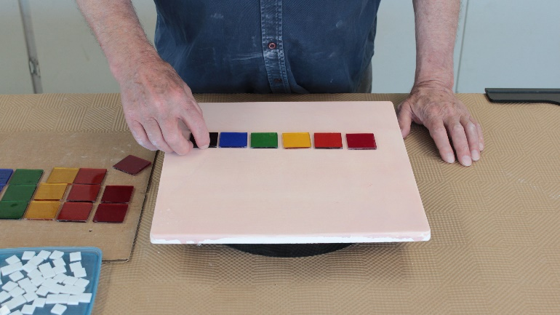

With the 4 rows of each of the different colors set out, use a straight edge to line them up.

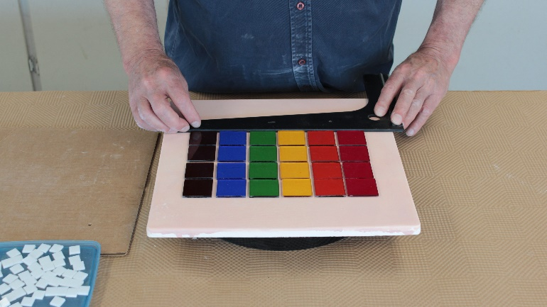  
  
Start placing the small ½ inch white squares at the middle of each square to act as bridges to connect all the colored squares.

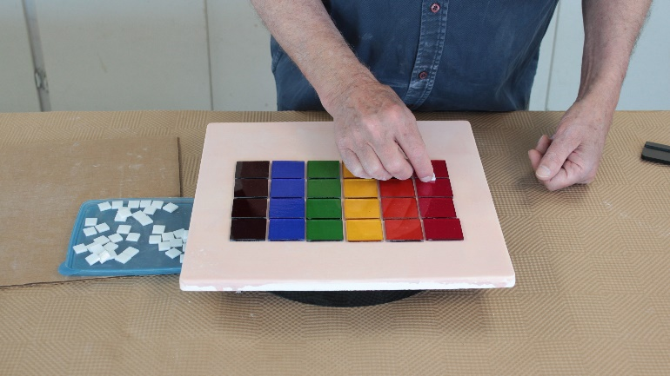  
  
I put them on a little sloppy here. No worries. I’ll straighten everything out when it’s in the kiln.

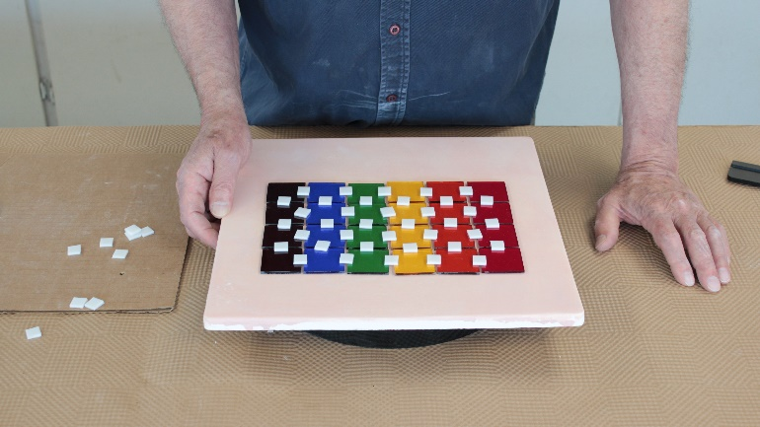

Fix the position of all the squares before firing. Here I’m using a dental pick. I like these for moving glass around on a kiln shelf.

