**SQUARED AWAY – Red & White Squares**

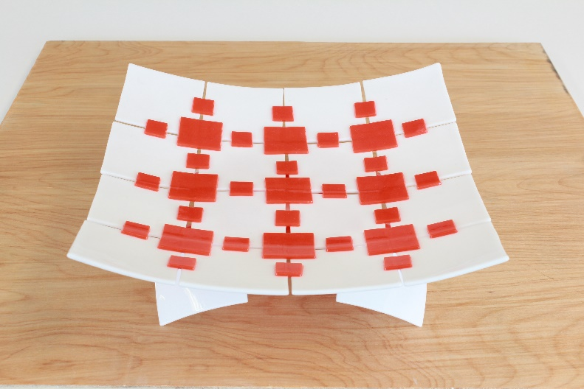

**Materials needed**

16 pieces 3” x 3” OGT 200.96 white opal glass

9 pieces 1 ½” x 1 ½” WIS 96.40 red opal glass

24 pieces ¾” x ¾” WIS 967.40 red opal glass

13” x 13” kiln paper

Set out the 16 squares of white glass on the kiln paper with even spaces between them.

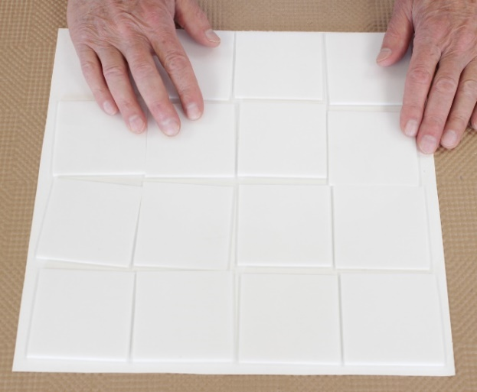

A piece of glass is a handy guide for spacing.

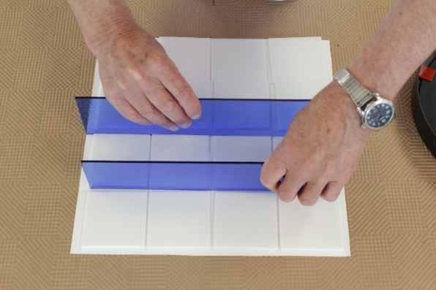

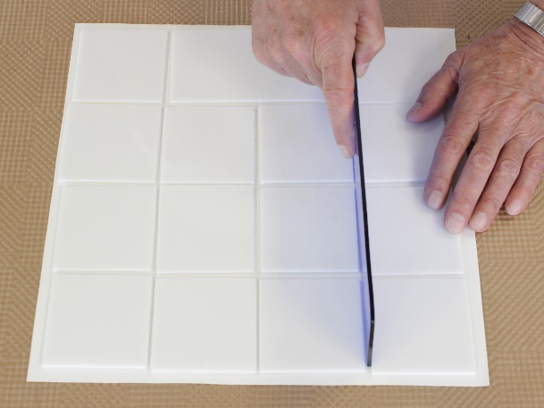

With all the white squares in place, set the 1 ½” red squares at the intersections between the white squares to connect all the white squares together.

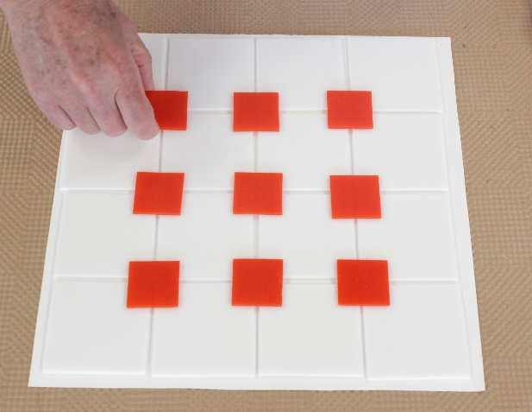

Set the small ¾ inch red squares halfway between each of the 1 ½ inch squares to bridge across the space between the white squares. These add extra stability to hold your project together.

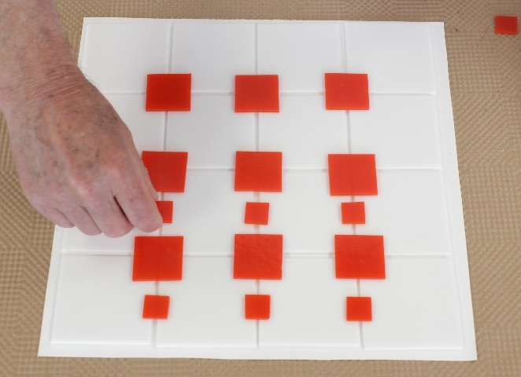

Set the rest of the ¾ inch red squares onto the assembly of white squares. Take care to space them evenly between the large red squares and centered over the space between the white squares.

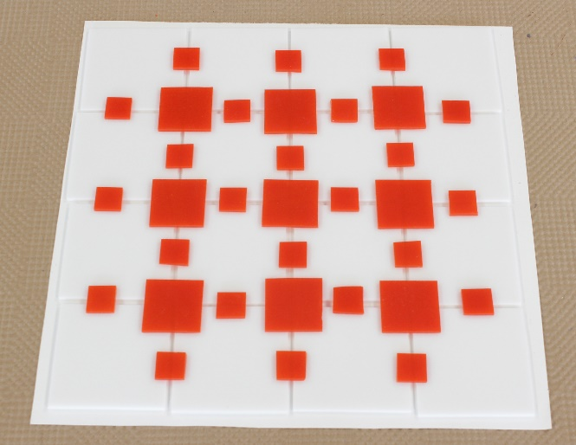

Fire the assembly to tack fuse

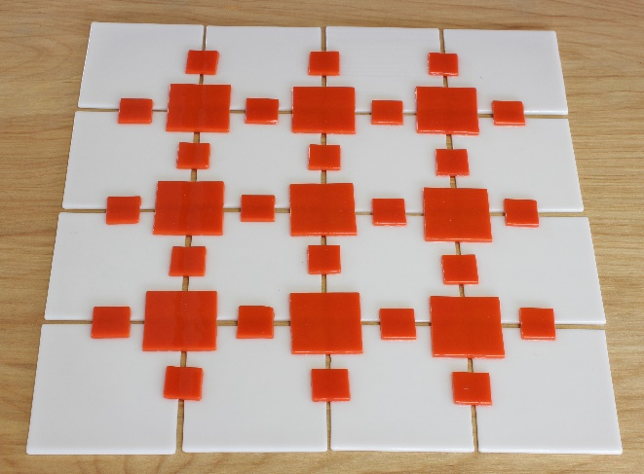  
  
Slump the tack fused project in a mold.

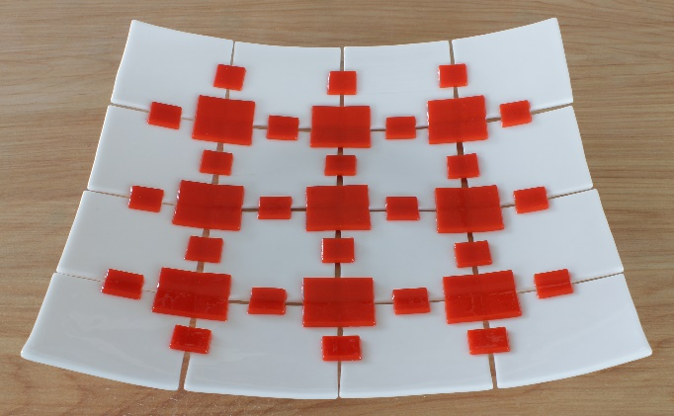

Make a matching stand to go with the tray.

